Holy Eucharist Rite II: The Ministry of the Word
Prelude Music
Processional Hymn #488……. “Be Thou My Vision ”
The service is followed in the Book of Common Prayer
Opening Sentence………………………………………p. 355
Gloria in Excelsis: “Glory to God”………………….… S280
Opening Collect………………………….……. bulletin insert
Old Testament Reading…………………..……. bulletin insert
Psalm…………………………………………..bulletin insert
New Testament Reading……………….… …… bulletin insert
Celtic Alleluia (Sung before and after the Gospel is read)
Gospel ……….. (All stand)…..…………….…. bulletin insert
Sermon:……………………....………The Rev. Mary Trainor

Nicene Creed…………………………………… .. …p. 358
Prayers of the People…………………. ….. p. 392(Form VI)
Those in need of our prayers: For healing: Elora, Mike, George, Bernie, Dan, Adeline, Bruce, Pam, Julie, Frances, Laura, Dave, Gary, Clark, Gerald, Nora, Brian, Kathleen, Ann, Wendy; Aaron, Ken, and all those deployed.
Diocesan Cycle of Prayer: Christ the King Holy Nativity, Sturgeon Bay and Jacksonport.

Confession and Absolution of Sin…………………..…p. 393
The Peace
Offertory Hymn #615..“Thy Kingdom Come”
"Praise God from whom all blessings flow"...Hymnal #380 v 3

The Great Thanksgiving
Eucharistic Prayer…Form B………………………….p. 367
Sanctus -“Holy, Holy, Holy”……. …………Hymnal # S130
All baptized Christians are welcome to receive Holy Communion
Post Communion Hymn #711…"Seek Ye First”
Concluding Prayer: ……………..…..…………………..p. 366
Blessing

Recessional Hymn .. Supplementary Hymnal#1…..“Open My Eyes”

Dismissal, Announcements and Postlude
++++++++++++++++++++++++++++++++++++++++
Please come to the Hall for refreshments and fellowship!

Welcome, visitors! Please see the pews for a special welcome card and information.

Today at St. John’s
During coffee hour eat, visit, learn from Pastor Mary about the lives of the saints! Inspiring stories!

11:10 AM = Bishop's Committee Meeting

Announcements
Please sign up on the clipboard in the Hall for the various roles of the church. There are many fun ways to serve.

Please check your mailbox in the Hall near the copy machine-- there is fun stuff in your mailbox!

The Bulletin Board is updated regularly, and there are announcements there for exciting events in the community and the Diocese. Take the time to read the Board!

Please bring non-perishable (canned or dried goods) foods to church and place them in the basket near the Church entrance; food is delivered weekly to the Shawano Food Pantry (check dates on food please). You can also bring cleaning supplies and toiletry items for those staying at the Shawano Domestic Abuse Shelter; please place these items in marked bins.

Look forward to a Fall education series on Spiritual Gifts in the Fall. Find out what spiritual gifts are, and what your special gifts are, in an objective and interesting way.

Interesting Discussion Coming! The Wednesday Group, which will be meeting both at 11 AM and 6:30 PM in the Hall beginning in September, will study Barclay's book on Luke (obtain copy on library shelf in Hall).

Education for Ministry (EfM) is now forming groups in the area for the Fall. Great way to learn more about your faith, the bible, history in a seminar group. If you are interested in learning more about EfM, see Pastor Mary. Brochures can be found in the Hall.

St. John's Upcoming Events:
August 4,11,18: mini-classes: Lives of the Saints
September 1: 11 AM Bishop's Committee Meeting
September 8: 9:30 AM Outdoor mass, parish picnic and pony rides for children
September 8: 1:30 PM: Blessing of the Animals

PICK UP IN THE RACK IN THE HALL:
- flyers that tell you about St. John's
- copies of today's sermon
- copy of the Church and Diocese electronic newsletter
- tracts that help with life's issues

Ways to get involved at St. John's:
See the bright yellow "Menu" of ministries at St. John's, which give you information on the many ways to serve and get involved at St. John's, and lets you know the contact person for each ministry.

Diocesan Calendar
8/18: Diocesan Party for Bishop Jacobus and his wife Jerrie, at Homestead Meadows Farm, Appleton 3:30-9 (obtain tickets now for this event on the Diocesan Website)
10/2: Bishop candidates - meet them at St. John's, Wausau
10/18-19: Diocesan Convention, Fond du Lac (elect new bishop)
4/26/14: Consecration of the new Bishop of Fond du Lac

St John’s staff:
Vicar- The Rev. Mary S. Trainor; Organist – Ted Myers
Bishop’s Committee: Senior Warden - Ron Stezenski; Jr. Warden- Art Frieberg; Marlene Brown, Nancy Clasen, Joe Keberlein, Wendy Hafner, LouAnne Zander; Treasurer - Sue Sazama; Clerk – Lois Renner; Youth Liaison, Ted Myers.

The Tenth Sunday after Pentecost
July 28, 2013
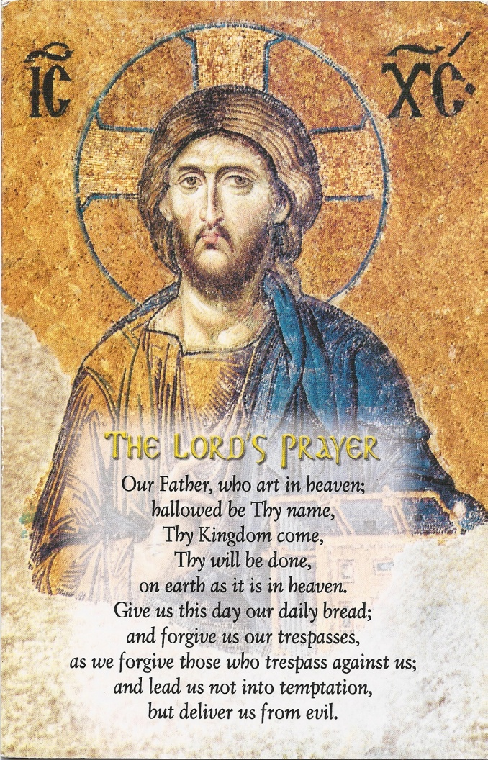

St. John’s Episcopal Church

141 South Smalley St., Shawano, WI

http://www.shawanoepiscopal.org

The Rt. Rev. Russell Jacobus, Bishop

The Rev. Mary S. Trainor, Vicar

Church Phone 715-526-3686

Vicar’s Phone 715-252-4816

pastormaryt@gmail.com

